Funding distribution by category
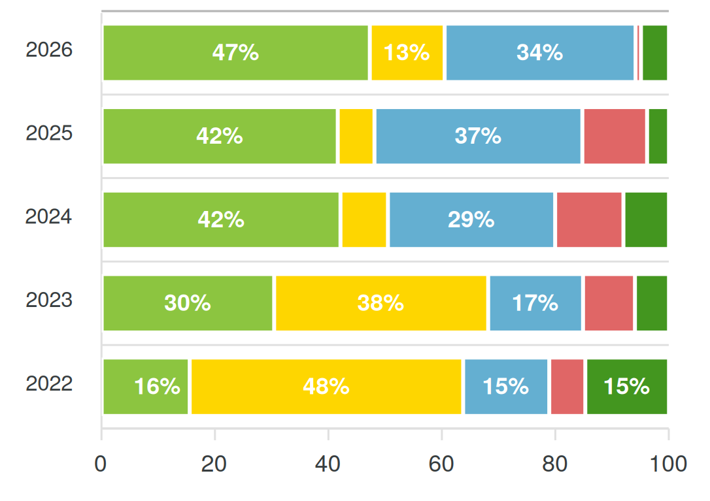
■ Support for military personnel and their families ■ Humanitarian aid ■ Adaptation, safe environment / home repair costs
■ Community support ■ Volunteer initiatives

Distribution by region
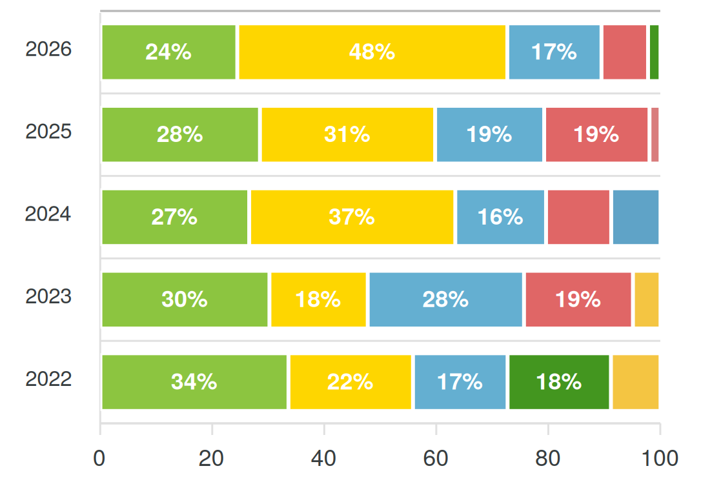
■ Vinnytsia region ■ Sumy region ■ Khmelnytskyi region ■ Kyiv region
■ Chernihiv region ■ Ternopil region ■ Kyiv city ■ Zhytomyr region

Detailed breakdown of fund usage
